Operation Manual
HM5002 Transformer DC Winding Resistance Tester

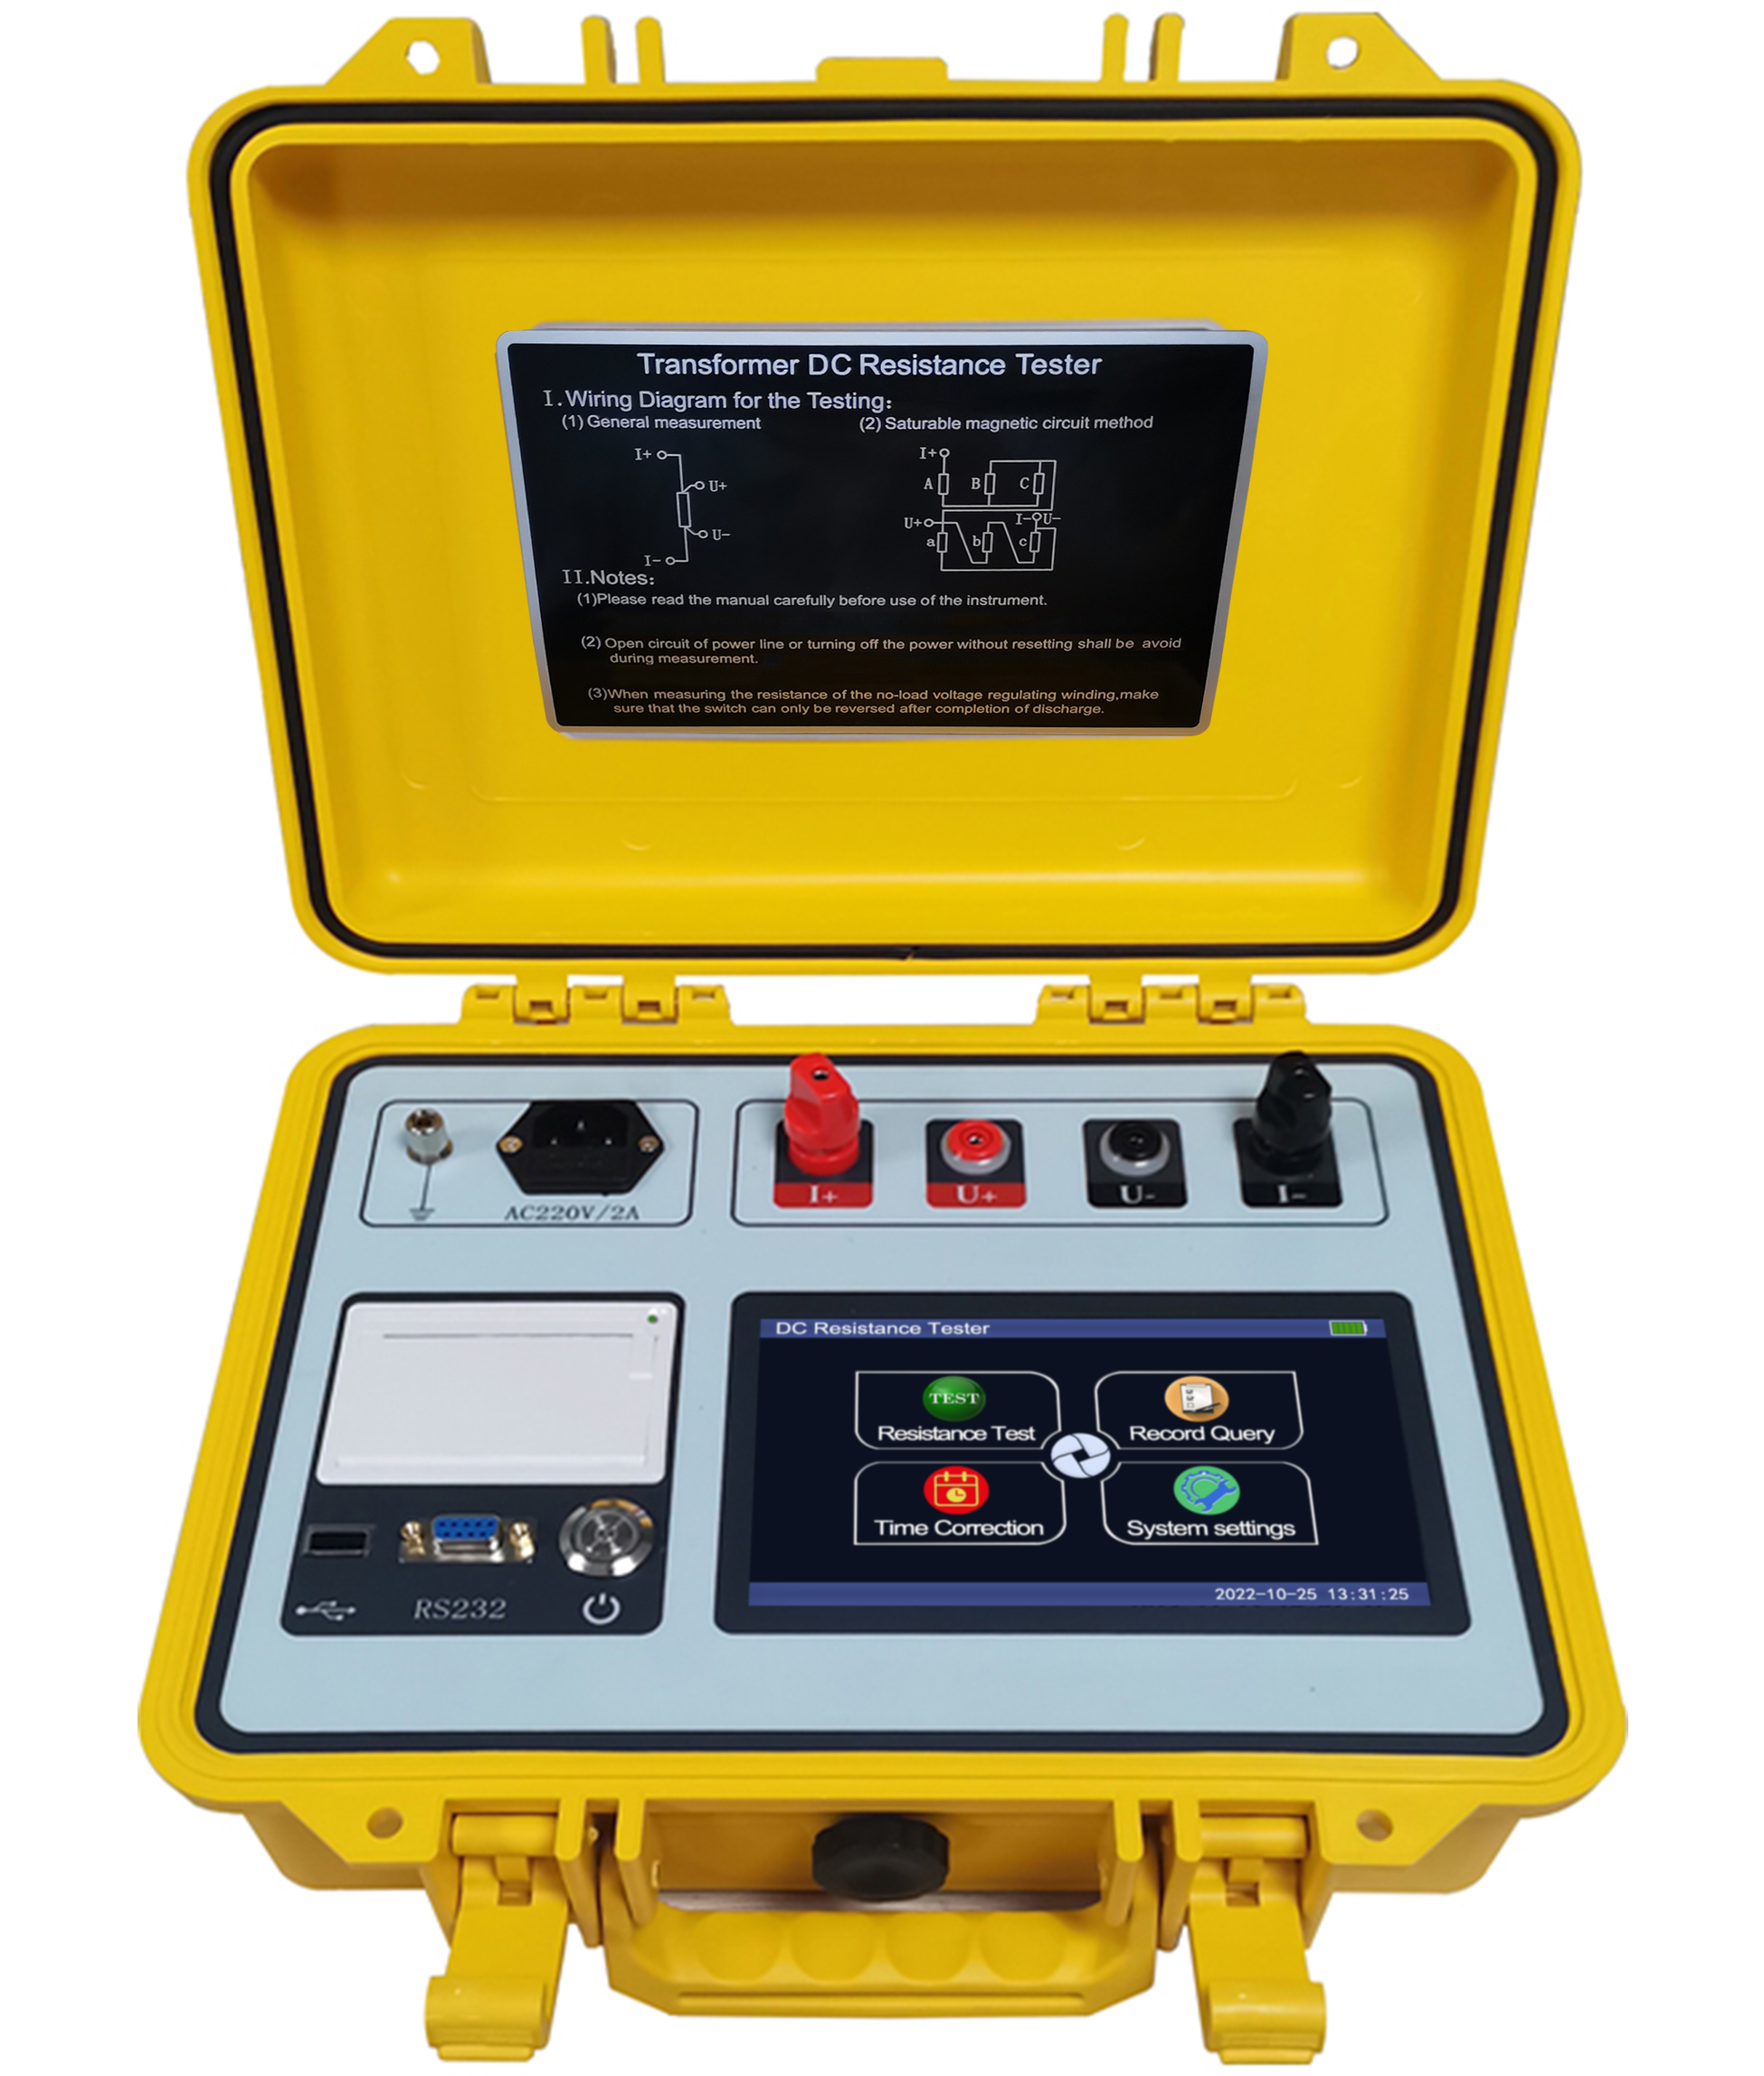

WUHAN GOLDHOME HIPOT ELECTRICAL CO.,LTD
Tel.：+86-13720185294 Fax：+86-27-84620387
Email: goldhome02@cablehipot.com Web.: www.hvcablehipot.com
Add.: No.A25-1, Huading Mould Industrial Park, Hannan, Wuhan, Hubei, China

Manual Instructions
Dear customer, greetings! First of all, we greatly appreciate your choice of our company's testing instrument. To expedite your proficiency of the instrument, please make sure to read the instructions in manual in detail.
This manual mainly introduces the use of this instrument. Please adhere to the instructions herein to ensure the safe and best operation of the instrument.

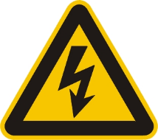
- Please comply with the national safety regulations for preventive testing of safety tools in the electric power industry, and any operation in flammable, explosive, and humid environments and other harsh conditions is prohibited;
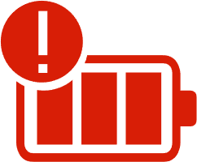
- This instrument is equipped with a large-capacity lithium battery, whose lifespan and performance are influenced by the frequency of charge and discharge cycles. If unused for a long time, conduct monthly charge and discharge maintenance on the battery.

- Unauthorized disassembly of the instrument is prohibited without the permission of our company. Any instrument failure due to unauthorized disassembly shall not be covered by warranty or eligible for return, and for any personal or property damage arising therefrom, our company shall not be held responsible.

- To continuously improve and optimize the product functions, we will update the specifications of this instrument periodically. Therefore, the instrument you are using may have slight differences from the manual. If you have any questions, please call our company and we will send professional engineers to provide operation guidance.

Contents
I. Overview 3
II. Safety measures 3
III. Performance characteristics 3
IV. Technical indicators 4
V. System introduction 5
VI. Test and operation method 7
VII. Precautions 18
VIII. Instrument packages 19
IX. After-sales service 19

Please read the operation manual carefully before using the instrument. It is the user's responsibility to ensure safety.
Version number of this manual: 20240131
This manual is subject to change without notice.
I. Overview
The measurement of direct current (DC) resistance is a required test item for the factory test, installation and handover test of semi-finished products and finished products in the manufacturing of inductive coils such as transformer, mutual inductor, reactor and electromagnetic operating mechanism, as well as the preventive test of the power department, which can effectively identify the manufacturing defects such as material selection, welding, loose connection, missing strand and disconnection of inductive coils and the hidden dangers after operation. In order to meet the needs of rapid measurement of inductive coil DC resistance, we have developed DC resistance tester depending on our own technical advantages. The instrument adopts a new power supply technology, which features small size, light weight, large output current, wide range, digital display, two power supply modes including mains supply and internal lithium battery. The whole instrument is controlled by a single chip microcomputer and has the functions of multi-current gear selection, data processing display, discharge indication, etc. The instrument features high test precision and simple operation, which can realize the rapid measurement of DC resistance.

II. Safety measures
1. Be sure to read this manual carefully before using the instrument.
2. The instrument can be used both indoors and outdoors, but it should be kept away from rain, and corrosive gas. Violent vibration of the instrument should be avoided.
3. Repair, maintenance and adjustment of instruments should be performed by professionals.
4. After the test, be sure to wait for the discharge alarm to stop before turning off the power supply and removing the test line.
5. When measuring the no-load voltage regulation transformer, be sure to switch the gear after the discharge indication alarm stops.
6. During the testing process, it is prohibited to move the testing clamp and disconnect the power supply circuit.

III. Performance characteristics
1. The instrument has large output current and light weight.
2. The instrument provides 7 output current options, the maximum output current being 10A.
3. It is equipped with perfect protection circuit for more reliable performance, and discharge audio alarm to reduce disoperation.
4. The instrument has a wide measuring range (0.5mΩ-100KΩ), where different sample temperatures can be set, and converted resistance value can be calculated automatically.
5. The instrument can calculate the three-phase imbalance rate, providing a quick and intuitive understanding of the stability of the transformer.
6. The instrument is powered by a built-in lithium battery and equipped with an independent charging system, which is convenient for on-site operation.
7. The instrument is equipped with a 7-inch color touch screen with a resolution of 800×480 pixels. It can be configured with Chinese/English operation menus and print the output results in real time.
8. The instrument adopts two power supply modes, i.e. AC and DC, to meet the use requirements of different sites (AC and DC mode involves the same testing and wiring methods except for different power supply modes).
9. With RS232 interface, the test data can be transmitted to the backend.
10. This instrument has a powerful storage function, capable of storing up to 1000 test records.
11. With a USB interface, the test data can be transferred to a USB flash drive.
12. The parameter settings are more comprehensive, allowing for the setting of the transformer's test winding, tap position, test phase, sample temperature, converted temperature value, winding material, etc.

IV. Technical indicators
1. Output current: 10A, 5A, 1A, 100mA, 10mA, 1mA, automatic;
2. Range:
0.5mΩ～1.6Ω (10A gear)
20mΩ～3.2Ω (5A gear)
100mΩ～16Ω (1A gear)
16Ω～100Ω (100mA gear)
100Ω～2kΩ (10mA gear)
2kΩ～100kΩ (1mA gear)
3. Accuracy: ± (0.2%+2 characters);
4. Resolution: 0.1μΩ;
5. Working temperature: -20 to 40℃;
6. Ambient humidity: ≤80% RH, no condensation;
7. Altitude: ≤1,000m
8. Working power supply: AC220V±10% 50Hz±1Hz; 24VDC/6Ah lithium battery;
9. Dimension: 323*275*135mm;
10. Weight: 4.75kg.

V. System introduction
The instrument panel is shown in the figure below:
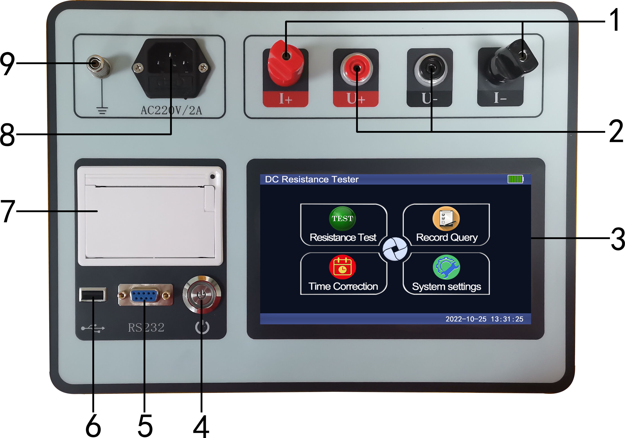
Figure 1
1. I+, I-: Flat cap terminals for current input/output, red for positive and black for negative.
2. U+, U-: Voltage input terminals, red for positive and black for negative.
3. LCD: 7-inch color touch LCD screen, displaying menus, current, and resistance values, etc. Avoid prolonged exposure to sunlight and heavy pressure.
4. Switch: The button switch to control the power supply of the instrument. When connected to the mains, the power supply of the whole instrument is AC; when not connected to the mains, the power supply of the whole instrument is internal lithium battery.
5. RS232: The instrument adopts a standard RS232 interface, which can be connected with the communication port of the upper computer. The instrument communicates with the PC according to the specified protocol. Both parties shall set the same baud rate and communication address to operate the instrument in real time and realize the functions of setting, measurement, data storage and transmission.
6. USB port: The connection and communication interface between the instrument and the USB flash drive is used to export memory data; the USB flash drive can be used to import data as a transfer port; the USB flash drive is connected to the computer for data transmission.
7. Printer: Miniature thermal printer, which will print test data and information when testing is completed to display or retrieve data: the printer uses 58mm thermal printing paper. When replacing the paper, open the paper compartment, insert the paper roll and leave a small portion outside, then close the cover.
8. Power socket: The instrument is connected to the mains power port and charging port.
Mains power port: The input voltage required for the instrument power supply is between AC200V and AC240V. The fuse holder is integrated with the power socket, and the fuse specification is 2A. When replacing the fuse, make sure to use a fuse of the same specification. (If the fuse still burns out after replacing it with a spare fuse, there may be a malfunction in the instrument. Please contact the manufacturer for timely assistance.)
Charging port: When the instrument is connected to the mains power, the built-in charging system starts charging the battery. Charging stops when entering the current selection interface and testing interface during use. Charging can be done normally when entering other interfaces or in shutdown state.
9. Grounding rod: Used for grounding the shell of the whole instrument, connected to the grounding wire of the power socket. Ensure reliable and independent grounding of the instrument before use. Check the grounding rod carefully for any paint or rust, as it may result in unreliable grounding.

VI. Test and operation method
(I) Test wiring
A. Single-phase measurement method, see the figure below
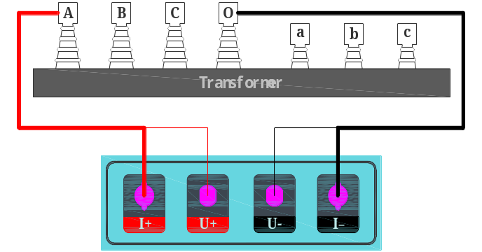
Figure 2
B. See Fig. 3 ~ 5 for the wiring of magnetic aid method (applicable to Y_{(N)}-d-11 connection group).
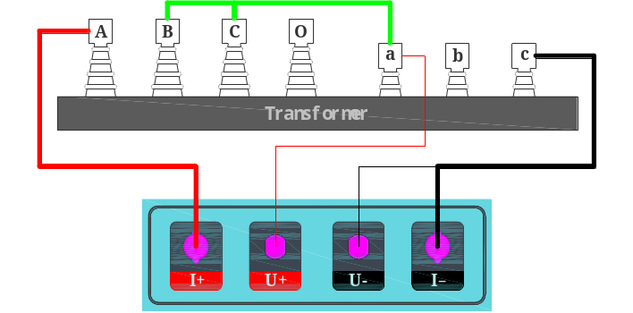
Figure 3
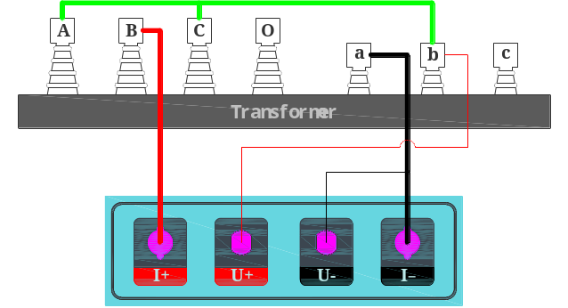
Figure 4
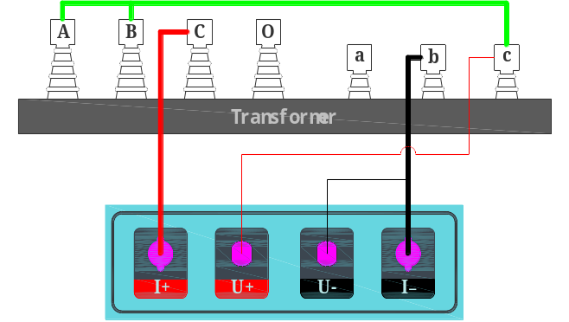
Figure 5
For low-voltage side measurement of large-capacity transformers, the maximum current of the DC resistance tester is relatively small. Alternatively, to speed up the measurement process, magnetic-assisted measurement can be chosen. Figure 3, Figure 4 and Figure 5 above shows the wiring method for measuring low voltage Rac, Rba and Rcb respectively.
- Operation method
1. Instructions for charging operation:
When the instrument is turned off, the charging system will automatically start charging after the power socket is connected to the power cord.
When the instrument is powered on, after the power socket is connected to the power cord, the battery icon in the interface will show the progress flow ability, indicating that the charging is in progress (when the instrument enters the current selection interface and the test interface, the charging stops); when the battery is fully charged, the battery icon will no longer show flow ability and will appear as a green full state (try to fully charge the battery at one time without interruption during the charging process).
Battery maintenance. The battery is a consumable component, and its lifespan and usage environment are related to the number of charge and discharge cycles. If it is not used for a long time, please charge and discharge the battery every month for maintenance.
2. Instructions for functional operation:
(1) Main interface: turn on the power switch, start the instrument and enter the main menu. The interface displays four options: "Resistance Test", "Record Query", "Time Correction" and "System Settings". Select the corresponding option for operation according to the use condition. The startup interface is shown as follows:
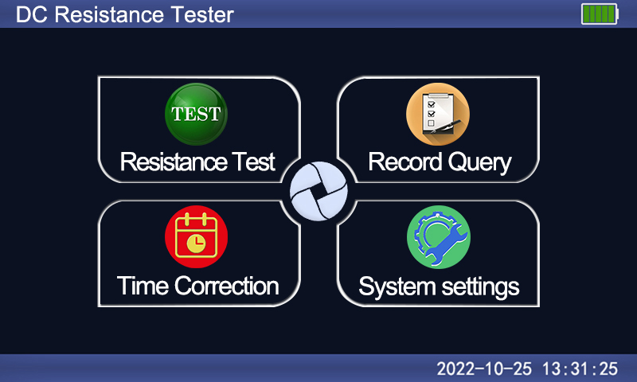
Figure 6
- DC resistance test: Enter the main menu interface after startup, click the "Resistance Test" menu to enter the current selection interface as shown in the figure below. First check the range of each current gear, and then select the appropriate test current according to the actual size of the tested object. When the resistance value of the tested object is not clear, the Automatic Test can be selected, and the instrument will automatically select the appropriate output current for testing according to the resistance value of the tested object.
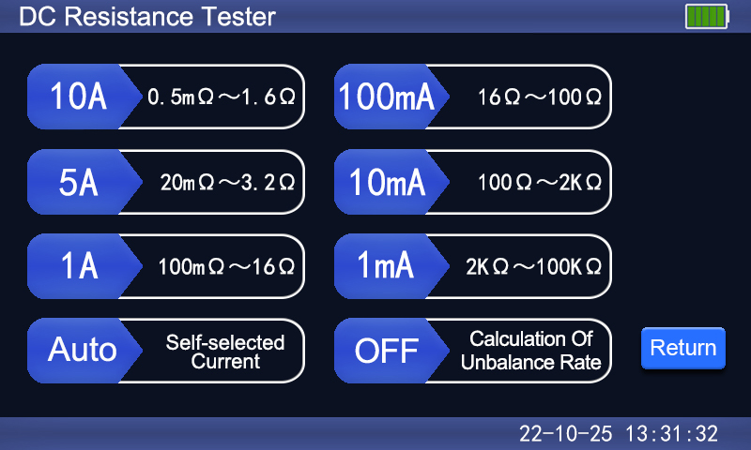
Figure 7
Click the required current gear, and the instrument executes the test command to enter the test interface. After the test current is charged stably, the LCD displays as shown in the figure below:
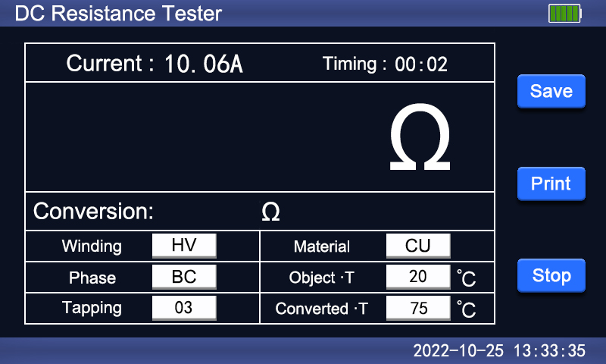
Figure 8
Click to modify the parameter values of Winding, Phase, Material category and Tapping, Object Temperature and Converted Temperature according to the actual situation on site.
Winding: The instrument displays three transformer winding types including high voltage (HV), medium voltage (MV) and low voltage (LV) in turn. Click on the display box to change the corresponding test winding.
Phase: The instrument displays six groups of transformer winding phases including AO/BO/CO/AB/BC/CA in turn. Click on the display box to change the corresponding test phase.
Winding material: According to different winding materials of transformer, click the display box to switch between the winding materials including copper and aluminum for different converted temperature coefficients.
Tapping: Click the display box, the interface will display a numeric keypad prompt. Input the corresponding tapping number and then click OK to enter it, and click ESC to return to the test interface, as shown in the figure below:
Object temperature: The default object temperature of the instrument is 20 ℃. Click the display box, the interface will display a numeric keypad prompt. Input the object temperature in the measurement environment, and click "OK" to save.
Converted temperature: The default conversion temperature of the instrument is 75 ℃. Click the display box, the interface will also display a numeric keypad prompt. Input the required or specified converted temperature, and click "OK" to save.
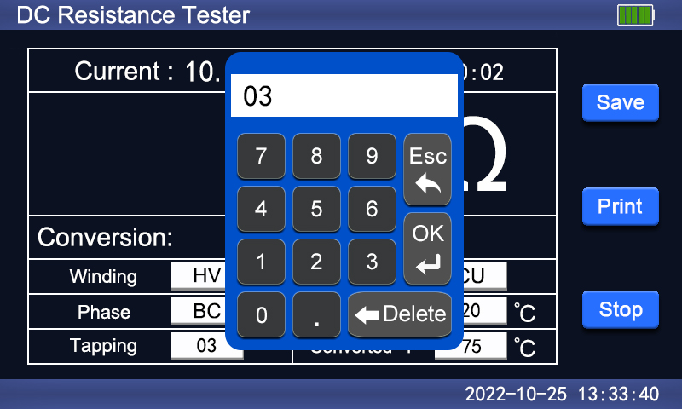
Figure 9
When the test resistance value is stable, the instrument will automatically calculate and display the test resistance value at the current temperature of the test object, and display the converted resistance value at the converted temperature, as shown in the figure below:
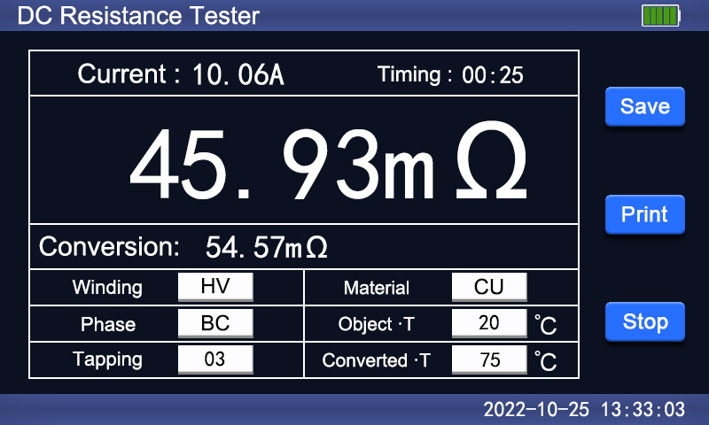
Figure 10
If you need to save the current data after the test, click the Save button, and the interface will show a "Saving, please wait..." prompt, indicating that the instrument is saving the test data. After a few seconds, the interface will show a "Saved successfully" prompt, indicating that the test data has been saved. As shown in the figure below:
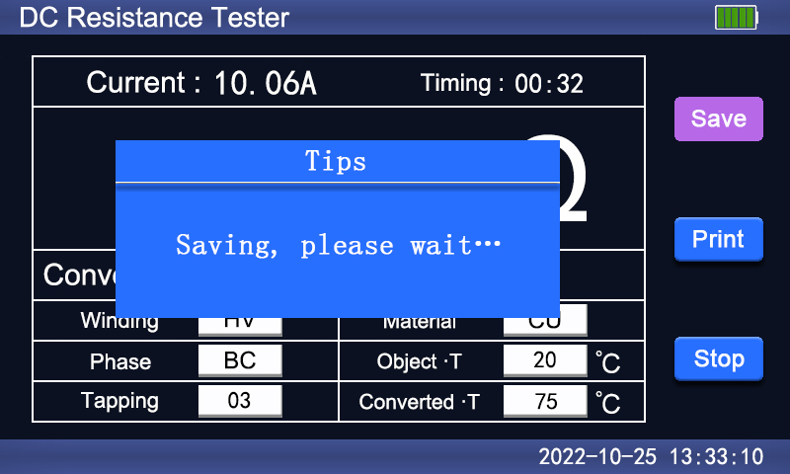
Figure 11
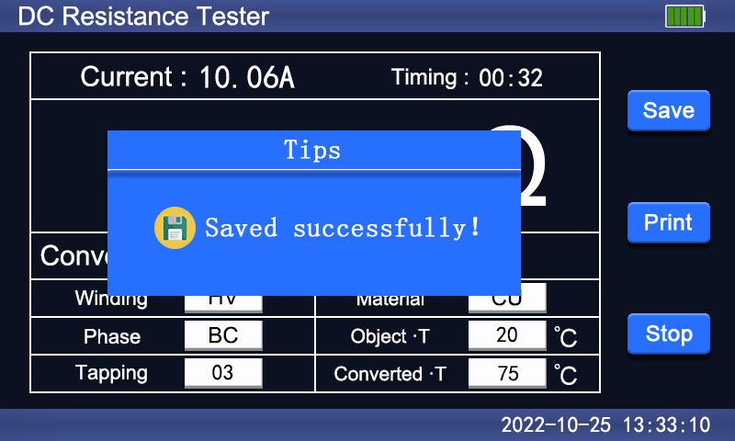
Figure 12
If you need to print the current data after the test, click the Print button, and the interface will show a "Printing, please wait..." prompt. The instrument starts to print the test data, and when the printing is completed, the interface will display a "Printing complete" prompt. As shown in the figure below:
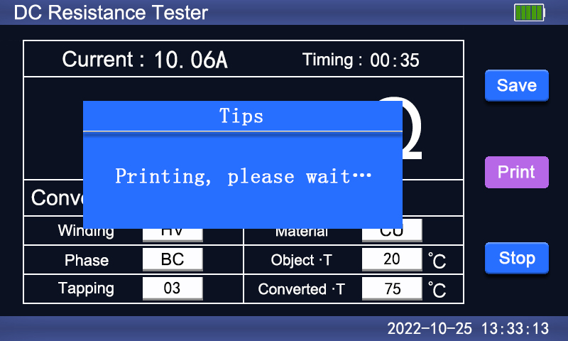
Figure 13
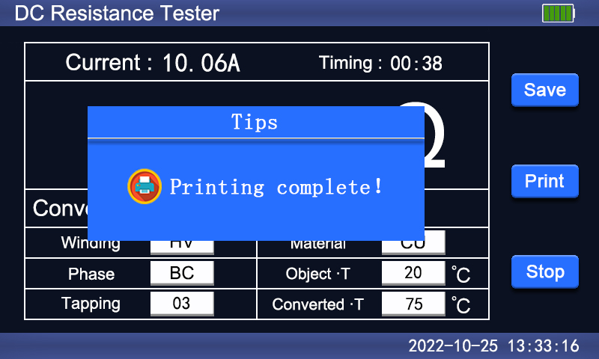
Figure 14
After that, click the Stop button to start the discharge of the instrument, and the LCD interface will show the prompt "Please do not remove the wire when discharging!" And there will be audible alarm, and LCD will return to the current selection interface. As shown in the figure below:
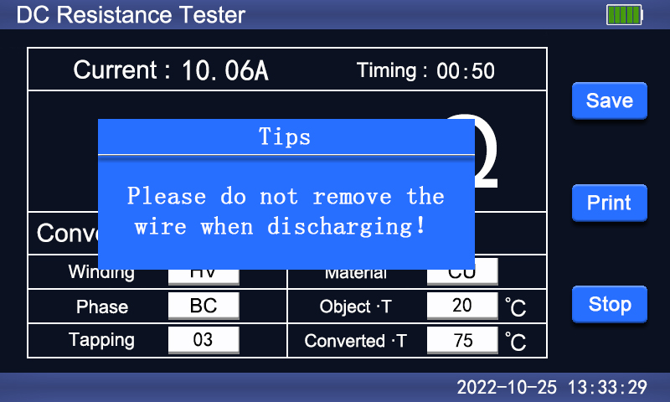
Figure 15
Unbalance rate calculation: The instrument has two states for calculating the unbalance rate, OFF and ON, which are displayed in a cyclic manner. The instrument is set to the default state of OFF (i.e., the calculation of the unbalance rate is not enabled). After pressing the button, it will display ON (i.e., the calculation of the unbalance rate is enabled). For example, click the Unbalance Rate Calculation option, the interface displays ON status, and then select the current gear. The instrument enters the test interface. When the test value is stable, set the test phase as AB, then click the Save button to save the test record, and select the Stop button to discharge, as shown in the figure below:
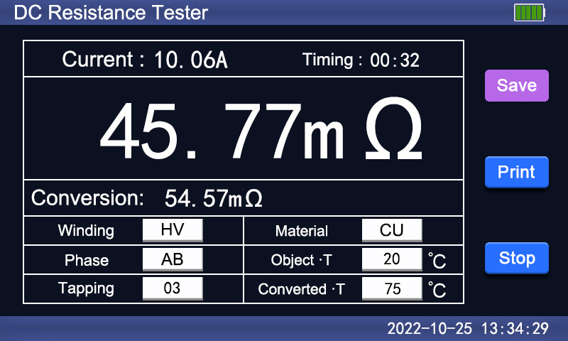
Figure 16
Test phase the BC phase in the same way, then click the Save button to save the test record, and select the Stop button to discharge, as shown in the figure below:
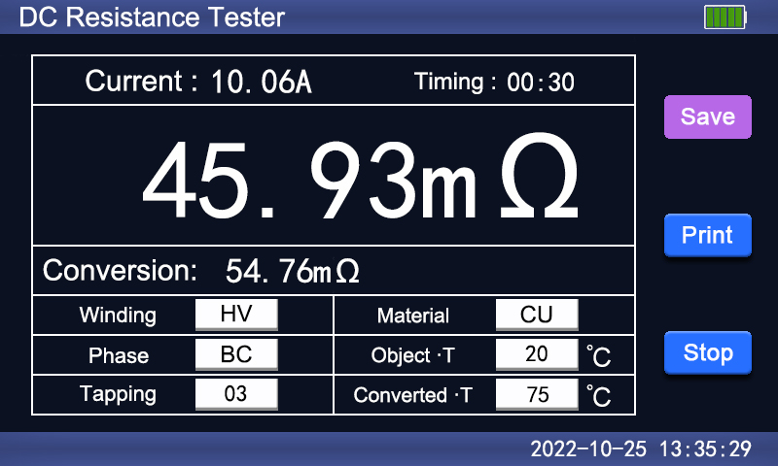
Figure 17
Finally, test the CA phase, and then click the Save button to display the test results for the three phases and the unbalance rate on the LCD. As shown in the figure below:
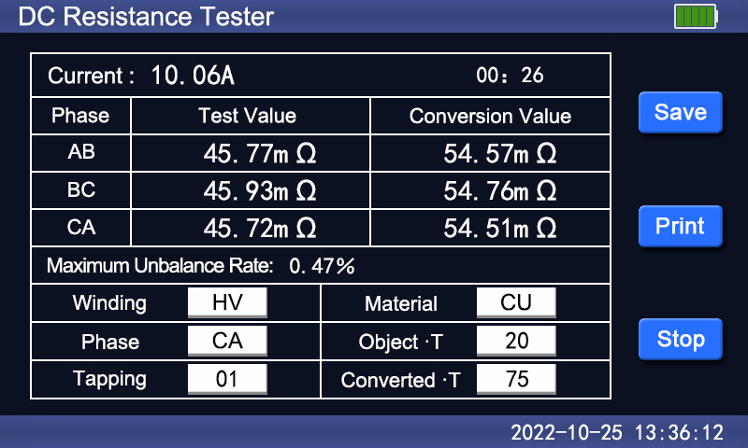
Figure 18
Note: When testing the inductive load, be sure to wait until the discharge alarm tone is over before rewiring for the next measurement, or turn off the power supply and remove the test wire!
(3) Record query: Enter the main menu interface after starting up, and click the "Record Query" menu to display the saved record data, as shown in the figure below:
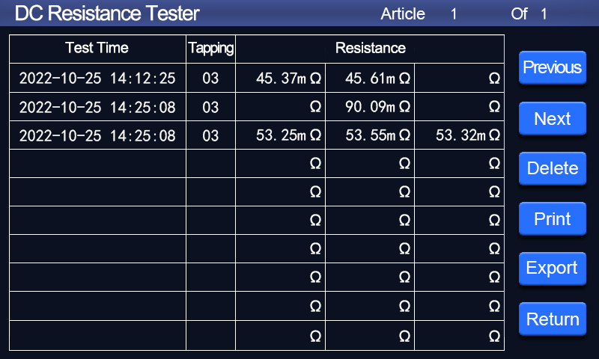
Figure 19
Previous and Next : Click the Previous button or the Next button to flip the page and view the saved test data.
Delete: Select the Delete button, and the interface will display "Deleting, please wait…" prompt box, and then the instrument deletes all test records.
Print: First select the data column to be printed, the font turns red after selection. Then click the Print button, and the interface displays a prompt box "Printing, please wait …". The instrument will start printing the selected test records until the printing is completed.
Export: First select the data column to be exported, the font turns red after selection. Then click the Export button. If the instrument is not inserted with a USB flash drive, the interface will display a prompt box saying "Please insert the USB flash drive". If the instrument is already inserted with a USB flash drive, the interface will display a prompt box saying "Exporting, please wait...". When the export is completed, the interface will display a prompt box saying "Export completed".
When the operation is completed, click Return to exit the record query menu.
(4) Time correction: Enter the main menu interface after starting up. Click the "Time Correction" menu to enter the interface, as shown in the figure below:
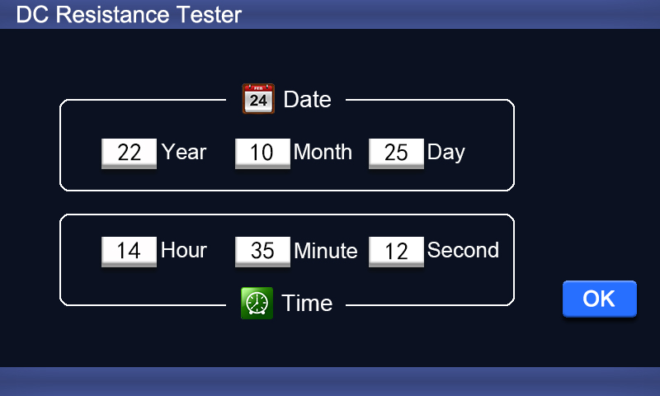
Figure 20
Click on the display boxes for "Year", "Month", "Day", "Hour", "Minute", and "Second", the interface will show a numeric keypad. To modify the values of the selected option, press the "OK" button. Enter the accurate value to correct the date and time, as shown in the figure below:
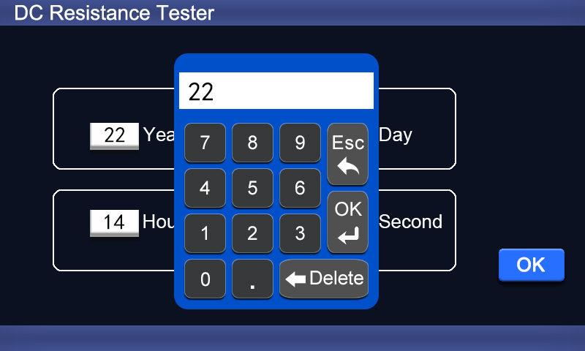
Figure 21
When the time and date are corrected, click the OK button, and the instrument will return to the main menu interface.
(5) System settings: Enter the main menu interface after starting up. Click the "System Settings" menu. System settings include three groups of options: Instrument Settings, Communication Parameters and Internal Debugging. Internal debugging is used for internal calibration before the instrument leaves the factory. The instrument enters the sub-interface of instrument settings by default, as shown in the figure below:
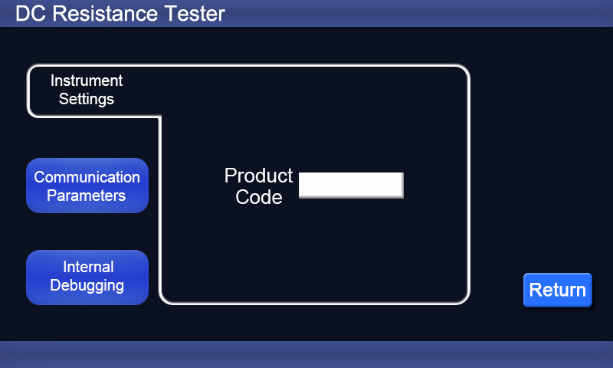
Figure 22
Product Code: Click the display box to pop up the numeric keyboard prompt. After the input is completed, click OK to save the product code. If the product code does not need to be modified, click ESC in the numeric keyboard to exit and return to the instrument settings interface.

VII. Precautions
1. Before measuring the transformer reverse tap line with no-load voltage regulation, be sure to wait until the discharge is over and the alarm stops before switching the tap point.
2. Before removing the wire, be sure to wait until the discharge is over, the alarm stops and the power supply is turned off.
3. When selecting the current, refer to the range in the technical indicator column. When it is used beyond the range, the actual test current cannot reach the standard test current value of this gear. In case of under-range, the current is too small, resulting in unstable data for large capacity transformers. When these two states occur, confirm the range and select the appropriate range for testing.

VIII. Instrument packages
Name | Quantity
DC resistance tester host | 1 set
Dedicated test wire | 1 set
Standard resistance | 1 set
Printing paper | 2 rolls
Power cord | 1 piece
Grounding wire | 1 piece
Fuse tube | 2 pcs.
User manual | 1 copy
Test Report | 1 copy
Packing list | 1 copy

IX. After-sales service
The tester can be replaced free of charge for any quality problem within 1 month from the date of purchase and can be repaired free of charge if there is a malfunction or problem within 1 year from the date of purchase(the battery has a warranty period of 6 months). The lifetime warranty and technical services are provided for the whole tester. For any abnormality or malfunction, please contact our company in time so that we can arrange the most convenient solution.

